|  |  |  |  |
| --- | --- | --- | --- |
| **FOR DISCUSSION/INFORMATION** | | | |
| Meeting: **Curriculum and Student Affairs and Outcome** | | | |
| Presented by | **Alan Moffat** | | |
| Author/Contact | **Alan Moffat** | Department / Unit | **Executive** |
| Date Created | **25/10/2024** | Telephone |  |
| Appendices Attached | **2** | | |
| Disclosable under FOISA | | **Yes** | |

1. **PURPOSE**

To update CSAO on NCL planning for Quality Enhancement

1. **BACKGROUND**

Report provided to CSAO provides update on developments taking place within the Quality department

1. **DETAIL**

The report includes information on Complaints, system development and staff development

1. **BENEFITS AND OPPORTUNITIES**

This report illustrates the importance of NCLs role within the sector to ensure that it provides public accountability and assurance on quality

1. **STRATEGIC IMPLICATIONS**

The Board retains an overview of NCL activity in the interests of good governance.

1. **RISK**

Non-compliance and institutional reputational risk

1. **FINANCIAL IMPLICATIONS**

Inability to achieve SFC credit targets could result in loss of income to New College Lanarkshire.

1. **LEGAL IMPLICATIONS**

There are no legal implications

1. **WORKFORCE IMPLICATIONS**

Activity should be manageable within current staffing levels

1. **REPUTATIONAL IMPLICATIONS**

Non-compliance and QAA sanctions

1. **EQUALITIES IMPLICATIONS**

There are no equality implications

|  |
| --- |
| **CONCLUSIONS/RECOMMENDATIONS**  CSAO are asked to note the information contained in this report and raise or discuss any issues which may prevent publication. |

### **1. INTRODUCTION**

This paper outlines the key improvements taking place within Quality Enhancement at New College Lanarkshire. It focuses on four critical areas:

1. Complaints handling and reporting

2. Systems development for internal verification

3. Curriculum review incorporating AI in learning and teaching

4. Review of professional services and staff development within the Quality department

### **2. Complaints Handling and Reporting**

To enhance the student experience, we have met as a team to look at how we can make improvements relating to the complaints handling process.  

**Streamline Reporting**: the online portal for students to submit complaints easily can be accessed on the Student Portal MyDay (Desktop and App). FORAP 21.1.1 Complaint entry form ensures issues are logged systematically and transparently, tracking through to Complaints Handling system that is sited on Infopoint.

At present, there are three members of NCL staff with Admin rights to the system:   
   
Jean Barclay (Complaints Handler)   
Alan Moffat (Interim Dean for Digital Learning and Quality Enhancement)

Ann Baxter (Deputy Principal for Students and Curriculum)

**Response Timeframes**: The organisation is duty bound to respond to Stage One and Stage Two complaints within a set timescale (recommended 5 and 20 days respectively). An additional member of the Quality team (Alan Moffat) was added as an Administrator in October 2024 to ensure compliance. He now also receives notifications of complaints via email and has a high-level view of complaints which can be reported at Executive Board level.

**Data Analysis and Reporting**: A system has been implemented that provides regular analysis of complaints data to identify trends and areas for improvement. This will continue to be reported quarterly to the Board to ensure a continuous overview and the quantitative and qualitative data will be used to inform the QAA SEAP.

**Complaints reporting**: There are two major changes which will take place around the reporting of complaints and the information gathered as part of organisational governance. The mechanism for making a complaint on the NCL website needs to be clearer for Third-party organisations and there is a proposal to elevate this within the corporate section of the website. Within the same section, members of the public will be able to view the latest report alongside previous Academic years.   
  
In addition to this, a “Lessons Learned Action Plan ” Template will be introduced to ensure we can better identify emerging issues and act on them to ensure we improve our level of service.

### **3. Systems Development for Internal Verification**

Our internal verification processes are currently undergoing review to ensure consistent and high-quality academic standards. Key improvements include:

**Internal Verification**: The Quality team are collaborating with Systems development to create a new QA system which carries out a two-stage verification process to ensure the information being submitted to MIS (Course Design Sheets, Timetabling, etc) can be synchronized with Internal Verification. The system will be designed to update in real time so that it reflects any curriculum changes that take place mid-year (staffing, semester delivery changes).

**Training Workshops**: Quality Assurance CPD will become mandatory for all Academic staff from August 2025. Thereafter, regular workshops for staff on best practice relating to internal verification will ensure that all team members are aligned with the latest standards and methodologies.

**Feedback Mechanism**: A Quality Enhancement subgroup consisting of Quality staff and Academic leaders across all departments will be established to ensure that the QA system continues to be refined.

### **4. Curriculum Review and the use of AI in Learning and Teaching**

The integration of AI into our curriculum will be a transformative step towards enhancing learning and teaching methodologies and align Education with the pace of change which is happening in Society.  Key actions include:

**Curriculum Alignment with AI Tools**: A comprehensive review is underway to determine how AI technologies can support personalised learning experiences using AI-driven tutoring systems (e.g. CoPilot). **See Appendix 2**

**Staff Training**: Development of staff training through the Staff Development Academy to equip Academic and Professional services staff with skills to effectively integrate AI into their roles and responsibilities.   
   
**Assessment Methods**: Revising assessment methods to incorporate AI tools that provide real-time analytics on student performance, allowing for intervention before formal assessment takes place.   
   
**Grading**: Using AI to feed qualitative data around proscribed assessment criteria to conduct a “pre-grading exercise” or first pass before being verified by a human. Particularly useful when using on Graded Units.

### **5. Staff Development**

Our Quality department is undergoing an internal review which is being led by the Interim Dean for Digital Learning and Quality Enhancement. Key initiatives include: -

**Skills Audit**: A staff skills audit will be carried out in November to identify gaps and opportunities for professional development within the Quality team.

**Continuous Professional Development (CPD**): For AY2425, a structured CPD program will be implemented that will focus on emerging trends in quality assurance and enhancement. This will ensure staff continue to understand the importance of educational standards and it will ensure that the Quality Team will have a comprehensive overview of the new QAA QE process and how this informs the Self-Evaluation and Action Plan.

**Cross-Departmental Collaboration**: Through the Heads of Department forum, collaboration between the Quality department and the Academic areas will be introduced so that opportunities are made available to share best practice and enhance service delivery. The Staff Development Academy will lead on this.

### **6. Conclusion**

The improvements being introduced are critical to advancing Quality Enhancement at New College Lanarkshire. These initiatives will not only enhance the student experience but also strengthen our commitment to academic excellence and continuous improvement.

### **Appendix 1 – Internal Verification System Overview**

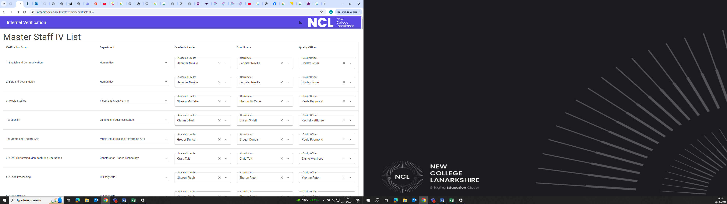

### **Appendix 2 – AI Pilot**

**Project Proposal: Learning Assistant Chatbot**

Objective:  
  
To develop a customized chatbot using Copilot Studio that assists students with course-related queries and provides support outside regular college hours.

Scope:

The chatbot will be designed to:

o Learn from existing learning materials: Utilize course content, textbooks, lecture notes, and other relevant resources.  
o Provide course-specific assistance: Answer questions related to subjects, assignments, projects, and exam preparation.  
o Operate beyond college hours: Offer 24/7/365 support to students.  
o Integrate with existing systems: Seamlessly connect with your college's website, student portal, and communication channels.

Proposed Approach:

1. Data Gathering and Grounding:

o Leverage Existing Learning Materials: Extract relevant information from course materials, textbooks, and lecture notes. Use generative answers to enable multi-turn chat over real-time data.  
o Prioritize Topics: Design conversational flows for critical topics (e.g., subject-specific queries, assignment guidelines).

2. Chatbot Creation in Copilot Studio:

o Create a Custom Agent:  
§ Describe the chatbot's purpose, instructions, triggers, and actions.  
§ Define knowledge sources (e.g., links to course materials, support documentation).  
§ Specify actions.

o Update Support Documentation:

§ Use feedback to update resources and knowledge bases.  
§ Collaborate with teams to recommend updates based on collected feedback.

3. Deployment and Integration:

o Channels:

§ Deploy the chatbot on multiple channels (e.g., college website, Microsoft Teams, custom mobile apps).

o Integration:

§ Integrate with existing systems (e.g., student portal, databases).  
§ Ensure seamless communication between the chatbot and students.

Benefits:

o Enhanced Student Experience: Immediate assistance for course-related queries.  
o Efficient Support: Reduces the load on college staff during non-business hours.  
o Personalized Learning: Tailored responses based on course materials.  
o Continuous Improvement: Feedback-driven updates to support documentation.

Responsible AI Considerations:

o Evaluate how Copilot aligns with your organization's business processes and regulatory requirements.  
o Ensure responsible AI principles are followed throughout the chatbot's development.