|  |  |  |  |
| --- | --- | --- | --- |
| **FOR DISCUSSION/INFORMATION** | | | |
| Meeting: **Curriculum and Student Affairs and Outcome** | | | |
| Presented by | **Alan Moffat** | | |
| Author/Contact | **Alan Moffat** | Department / Unit | **Executive** |
| Date Created | **25/10/2024** | Telephone |  |
| Appendices Attached | **2** | | |
| Disclosable under FOISA | | **Yes** | |

1. **PURPOSE**

To update CSAO on SFC/QAA plans for Quality Enhancement for the Tertiary Sector

1. **BACKGROUND**

Report provided to CSAO provides update on how QE and reporting is progressing Nationally and how this impacts on NCL position.

1. **DETAIL**

The report includes information on SFC/QAA TQEF process and NCL timelines

1. **BENEFITS AND OPPORTUNITIES**

This report illustrates the importance of NCLs role within the sector to ensure that it provides public accountability and assurance on quality

1. **STRATEGIC IMPLICATIONS**

The Board retains an overview of NCL activity in the interests of good governance.

1. **RISK**

SFC/QAA non-compliance and institutional reputational risk

1. **FINANCIAL IMPLICATIONS**

Inability to achieve SFC credit targets could result in loss of income to New College Lanarkshire.

1. **LEGAL IMPLICATIONS**

There are no legal implications.

1. **WORKFORCE IMPLICATIONS**

Activity should be manageable within current staffing levels

1. **REPUTATIONAL IMPLICATIONS**

Non-compliance and QAA sanctions

1. **EQUALITIES IMPLICATIONS**

There are no equality implications.

|  |
| --- |
| **CONCLUSIONS/RECOMMENDATIONS**  CSAO are asked to note the information contained in this report and raise or discuss any issues which may prevent publication. |

### **1. INTRODUCTION**

This paper seeks to provide an overview of the Scottish Funding Council (SFC) and Quality Assurance Agency (QAA) project for enhancement within the Tertiary sector (Colleges and Universities)

### **2. Quality Enhancement Context**

In 2023, the Quality Assurance Agency (QAA) received the commission from Scottish Funding Council (SFC) to develop and deliver an enhancement-led external peer review for all Scotland's colleges and universities. This will be done in collaboration with partner agencies such as CDN, sparqs (Student Partnership in Quality Scotland) and SCQF.

Scotland’s Tertiary Quality Enhancement Framework (TQEF) contains a set of **principles**, **delivery mechanisms** and **outputs** which are designed to give assurance on academic standards and enhance the quality of the student learning experience. SFC have adopted a partnership approach to developing the TQEF and will be seeking peer and student reviewers to ensure the peer-led review model is adhered to. The review team will consist of Review Manager (QAA), peer reviewers and student reviewers.  

**Principles**:   
   
Excellence in Learning and Teaching   
Supporting Student Success   
Enhancement and Quality Culture   
Student Engagement & Partnership 

**Delivery Mechanisms**:   
   
Tertiary Quality Enhancement Review (TQER)   
Annual Quality Engagement (AQE)   
Institution-led Quality activity   
Scotland’s Tertiary Enhancement Programme (STEP)   
Use of Data and evidence for reporting 

**Outputs**:   
   
Quality Agency Reporting on review activity   
Self-Evaluation and Action Plan   
Impact Reporting of enhancement activity   
Effectiveness in responding to concerns 

The TQEF journey is designed to provide public accountability and assurance on quality.

The new external review cycle for colleges and universities will commence AY2425.  **See Appendix 1**

### **3. Tertiary Quality Enhancement Review (TQER)**

**Aim**: To answer the question: "Is the provision delivered by New College Lanarkshire of high quality and is it improving?"   
   
**Objective**: To create a Quality Enhancement framework which sets out to establish a centre of excellence in learning, teaching and assessment.  A culture of collaborative practice will be fostered which will support student success and engagement as well as encourage external engagement with key stakeholders and industry partners.

The Tertiary Quality Enhancement Review (TQER), is designed to support assurance and enhancement of academic standards. The TQER replaces previous arrangements (HGIOC and Annual Engagement review) and is designed to be cyclical, peer-led, with an emphasis on the importance of student engagement, data and evidence, and outcomes reporting.  A 7-year cycle has been agreed which will include an implementation year and a reflection at the end of the cycle. A QAA Liaison officer will support the reporting on quality assurance, improvement and enhancement.    
   
Some key features of the TQER are:   
   
Involvement with peer and student reviewers which will include site visits   
A focus on student voice. **See Appendix 2**

**Sparqs and Student Partners**

As part of the review process, students will be at the centre of the QE Framework and will be viewed as partners throughout. The new approach will work on the principle of “sector-owned enhancement” which places responsibility for the quality of service and provision that students receive onto individual institutions.

sparqs (student partnerships in quality Scotland) will continue to support students and work closely alongside FE/HE institutions to ensure representation and curriculum co-creation. They will also support the implementation of the Student reviewer process.

STEP (Scotland’s Tertiary Enhancement Programme) will establish a Steering Group, a Topic Leadership Group, and this will feed into the development of themes across the STEP Network.  The Steering Group will be represented by Colleges (4), Universities (4) and other key stakeholders including SFC, CDN and NUS.

Partner organisation CDN will be working closely with QAA during the Discovery Year (Year 1) where a series of Discovery Days will be held throughout.  

The first enhancement topic is called **Supporting Diverse Learning Journeys** and within this, themes such as learner pathways, community engagement, skills development and tailored personalised support will be explored.  

### **4. Annual Quality Engagement (AQE)**

The AQE has two aspects to it. Institutional Liaison meetings (ILMs) led by QAA and SFC engagement on monitoring of quality of provision. The Self-Evaluation and Action Plan (SEAP) will form the basis for annual engagement. ILMs will be managed through external peer reviews and institutions will be encouraged to seek advice on any additional information which will help the review in addition to the SEAP.

### **5. Self-Evaluation and Action (SEAP)**

From 2024-2025, the SEAP will be the only annual reporting on quality that institutions need to make to SFC. As part of the TQEF review cycle, institutions will not be required to submit a SEAP if they are undertaking a TQER. Instead they will submit a Strategic Impact Analysis (SIA) to QAA.   
   
The SEAP will allow institutions to reflect on quality assurance and enhancement activities and outcomes whilst planning strategic enhancement through the action plan. Key priorities will be how the SEAP acts as an evidence base for high quality learning and teaching, student engagement and strategic planning. SFC will use it as a marker for gauging the effective use and impact of public investment. QAA will use the SEAP as an evidence base for the TQER, annual institution progress and to support the ILMs.

### **6. NCL SEAP Plan**

**Purpose**   
   
The SEAP replaces annual reporting and acts as a tool for internal reflection, strategic planning and is a statement of assurance for both SFC and QAA.

**Preparation**

  The SEAP should be concise, focusing on high-level themes

Excluding the Action Plan, the self-evaluation should be approximately 5000 words

Evidence of how institutions have engaged with students as partners should be front and

centre of the SEAP process 

**NCL Approach**

The Assistant Principal is leading the SEAP process, supported by the NCL Deans.   
   
Excellence in Learning and Teaching (BS)   
Supporting Student Success (NM)   
Enhancement and Quality Culture (AM)   
Student Engagement and Partnership (JL)

The report will be underpinned by evidence of partnership and stakeholder engagement and will be driven by Data and Evidence and signed off by the Accountable Officer.

### **Appendix 1 -**

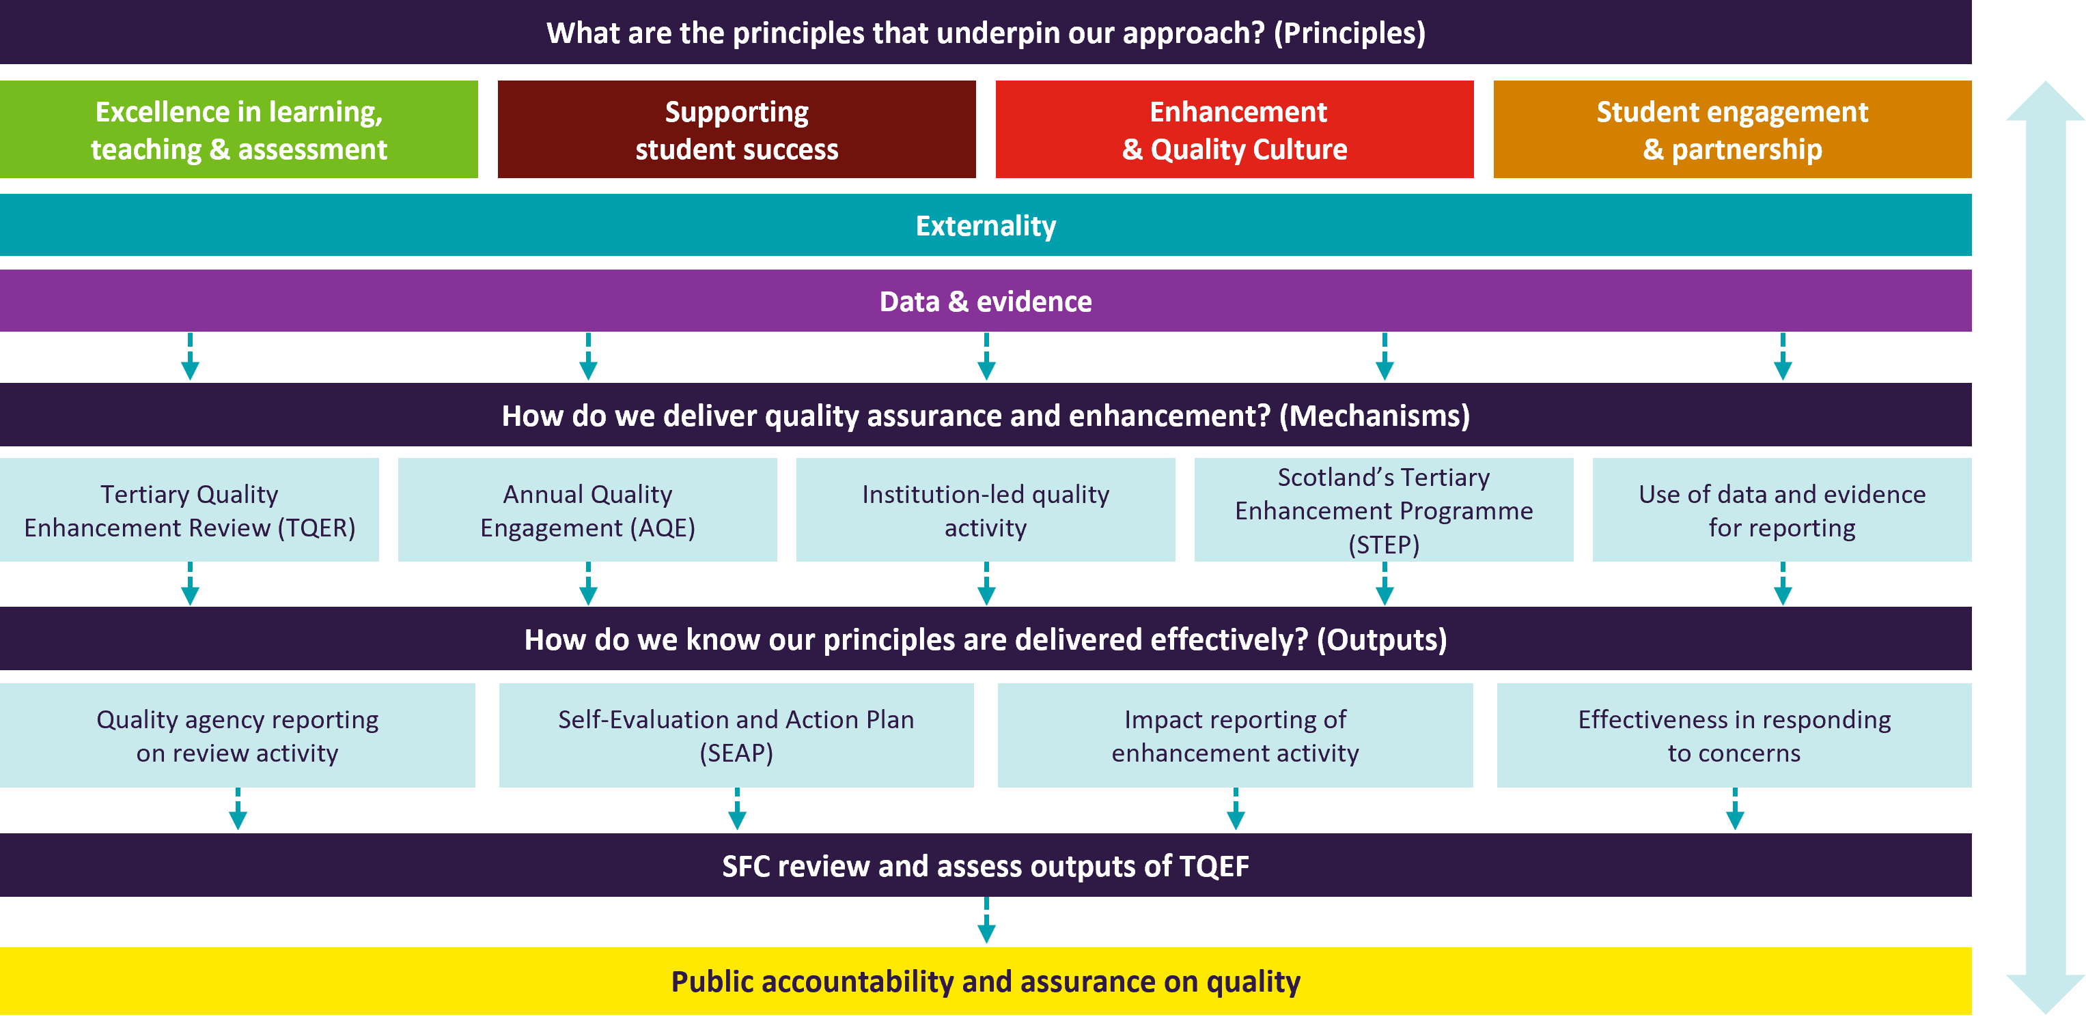

### **Appendix 2 –**

